# MyFitness Tracker Help and Documentation

# Entering/changing a Goal

1. Run Program
2. On Home Page, click Set Goal at the bottom

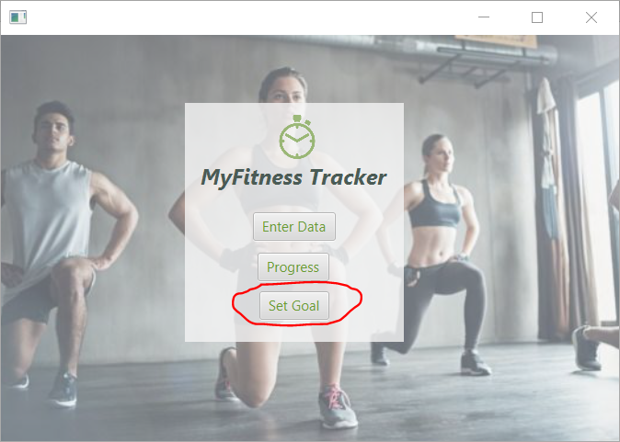

1. Once in Set Goal, choose a Category from the drop down, e.g. Step Count
2. Enter a Volume, e.g. 4000

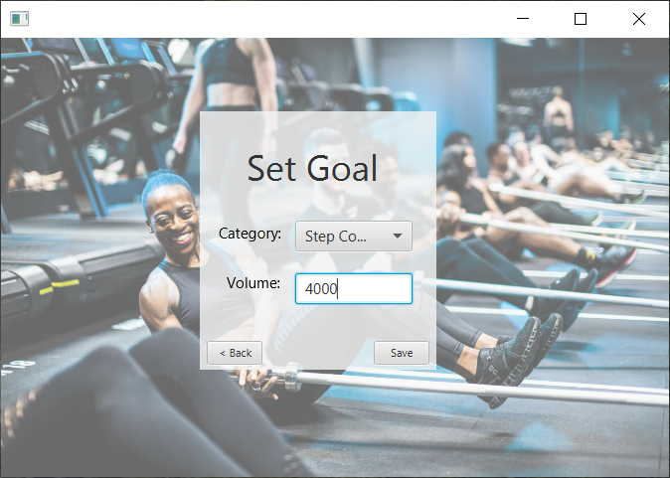

1. Click Save
2. Repeat Steps 3, 4 & 5 for all Categories as required
3. Once complete, click < back to return to the home page
4. To change your goal, simply re-enter your new goal in your desired category and the goal in the dashboard will over-write to the new goal

# Entering Data

1. Once back on Home Page, click Enter Data

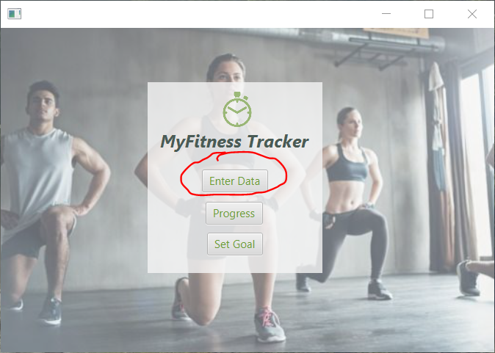

1. When in Enter Data, choose a category from the drop down, e.g. again Step Count
2. Enter a Volume, e.g. 2000
3. Enter a Date, e.g. 21/04/19

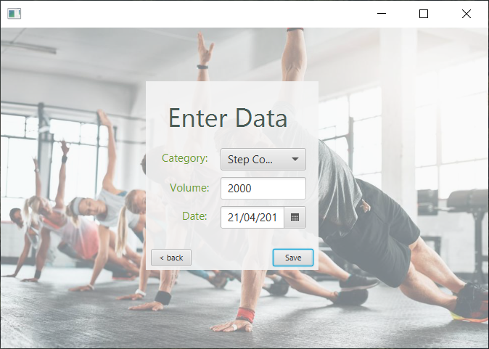

1. Click Save
2. Repeat steps 2, 3, 4 & 5 for all Categories as required
3. Once complete, click < back to return to the home page

# Viewing Your Progress

1. Once back on the Home Page, click on Progress

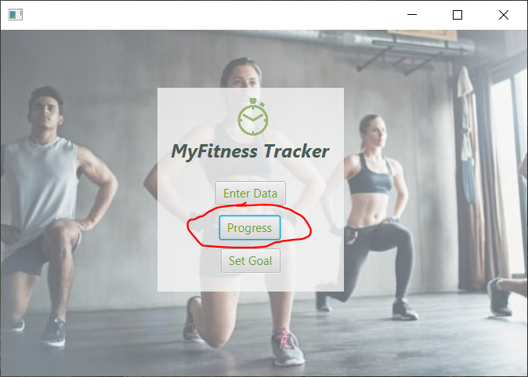

1. Once on the Fitness Dashboard, you can view all categories, their goals, and any entered data for a specific date

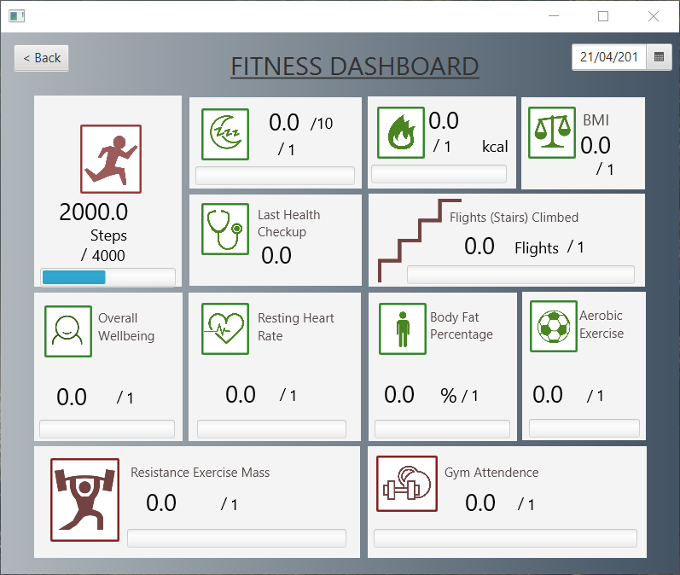

1. You can see the example we entered is 2000 steps with a goal of 4000 on the date of 21/04/2019 (full date cut off).
2. Any un-entered goals default to 1
3. Repeat steps for Entering data and Setting Goals as mentioned previously to achieve the full extent to the system